**My Jesus,**

**I believe that you are present in this Holy Sacrament of the altar.**

**I love you above all things and I passionately desire to receive you into my soul.**

**Since I cannot now receive you sacramentally,**

**come spiritually into my soul**

**so that I may unite myself wholly to you now and forever. Amen.**

*based on a prayer of St Alphonsus Liguori*

At the Saviour’s command

and formed by divine teaching, we dare to say:

**Our Father, who art in heaven,**

**hallowed be thy name;**

**thy kingdom come,**

**thy will be done**

**on earth as it is in heaven.**

**Give us this day our daily bread,**

**and forgive us our trespasses,**

**as we forgive those who trespass against us;**

**and lead us not into temptation,**

**but deliver us from evil.**

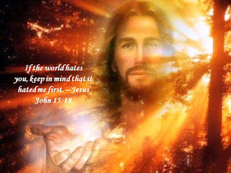**Concluding Prayer**

Rejoicing on this festival day, O Lord, we have received your heavenly gifts; grant, we pray, that we who in this divine banquet proclaim the death of your Son may merit with Saint George to be partakers in his resurrection and glory. Through Christ our Lord. Amen.

**Spiritual Communion - Solemnity of St George**

**Friday 23 April 2021**

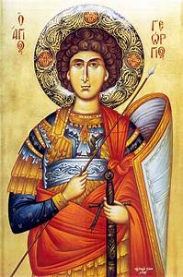

**Opening Prayer**

God of hosts, who so kindled the fire of charity in the heart of Saint George your martyr, that he bore witness to the risen Lord both by his life and by his death; grant us through his intercession, we pray,

the same faith and power of love, that we who rejoice in his triumph

may be led to share with him in the fullness of the resurrection. Through our Lord Jesus Christ, your Son, who lives and reigns with you in the unity of the Holy Spirit, God, for ever and ever. Amen.

**Apocalypse 12:10-12I,**

I John, heard a voice shout from heaven, ‘Victory and power and empire for ever have been won by our God, and all authority for his Christ, now that the persecutor, who accused our brothers day and night before our God, has been brought down. They have triumphed over him by the blood of the Lamb and by the witness of their martyrdom, because even in the face of death they would not cling to life. Let the heavens rejoice and all who live there.’

**The Word of the Lord**

**Romans 5:1-5**

Through our Lord Jesus Christ, by faith we are judged righteous and at peace with God, since it is by faith and through Jesus that we have entered this state of grace in which we can boast about looking forward to God’s glory. But that is not all we can boast about; we can boast about our sufferings. These sufferings bring patience, as we know, and patience brings perseverance, and perseverance brings hope, and this hope is not deceptive, because the love of God has been poured into our hearts by the Holy Spirit which has been given us.

**The Word of the Lord**

**Gospel Acclamation**

**Alleluia, alleluia!**

**Happy the man who stands firm,**

**for he has proved himself,**

**and will win the crown of life.**

**Alleluia!**

**Gospel John 15:18-21**

Jesus said to his disciples: ‘If the world hates you, remember that it hated me before you. If you belonged to the world, the world would love you as its own; but because you do not belong to the world, because my choice withdrew you from the world, therefore the world hates you. Remember the words I said to you: A servant is not greater than his master. If they persecuted me, they will persecute you too; if they kept my word, they will keep yours as well. But it will be on my account that they will do all this, because they do not know the one who sent me.’

**The Gospel of the Lord**

