My Jesus,
I believe that you are present in this Holy Sacrament of the altar.
I love you above all things and I passionately desire to receive you into my soul.
Since I cannot now receive you sacramentally,
come spiritually into my soul
so that I may unite myself wholly to you now and forever. Amen.

based on a prayer of St Alphonsus Liguori

At the Saviour’s command
and formed by divine teaching, we dare to say:
Our Father, who art in heaven,
hallowed be thy name;
thy kingdom come,
thy will be done
on earth as it is in heaven.
Give us this day our daily bread,
and forgive us our trespasses,
as we forgive those who trespass against us;
and lead us not into temptation,
but deliver us from evil.

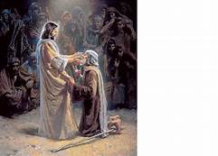
Concluding Prayer
May your Sacraments, O Lord, we pray, perfect in us what lies within them, that what we now celebrate in signs we may one day possess in truth. Through Christ our Lord. Amen.

Spiritual Communion
30th Sunday in Ordinary Time
Sunday 24 October 2021

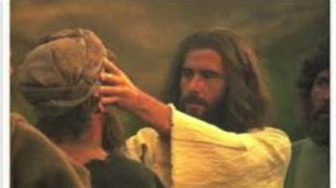

Opening Prayer
Almighty ever-living God, increase our faith, hope and charity, and make us love what you command, so that we may merit what you promise. Through our Lord Jesus Christ, your Son, who lives and reigns with you in the unity of the Holy Spirit, God, for ever and ever. Amen.

Jeremiah 31:7-9
The Lord says this: Shout with joy for Jacob! Hail the chief of nations!
Proclaim! Praise! Shout: ‘The Lord has saved his people, the remnant of Israel!’
See, I will bring them back from the land of the North and gather them from the far ends of earth; all of them: the blind and the lame, women with child, women in labour: a great company returning here.
They had left in tears, I will comfort them as I lead them back; I will guide them to streams of water, by a smooth path where they will not stumble. For I am a father to Israel, and Ephraim is my first-born son.
The Word of the Lord

Responsorial Psalm
What marvels the Lord worked for us! Indeed we were glad.

When the Lord delivered Zion from bondage,
it seemed like a dream.
Then was our mouth filled with laughter,
on our lips there were songs.

The heathens themselves said: ‘What marvels
the Lord worked for them!’
What marvels the Lord worked for us!
Indeed we were glad.

Deliver us, O Lord, from our bondage
as streams in dry land.
Those who are sowing in tears
will sing when they reap.

They go out, they go out, full of tears,
carrying seed for the sowing:
they come back, they come back, full of song,
carrying their sheaves.

Hebrews 5:1-6
Every high priest has been taken out of mankind and is appointed to act for men in their relations with God, to offer gifts and sacrifices for sins; and so he can sympathise with those who are ignorant or uncertain because he too lives in the limitations of weakness. That is why he has to make sin offerings for himself as well as for the people. No one takes this honour on himself, but each one is called by God, as Aaron was. Nor did Christ give himself the glory of becoming high priest, but he had it from the one who said to him: You are my son, today I have become your father, and in another text: You are a priest of the order of Melchizedek, and for ever.
The Word of the Lord

Gospel Acclamation
Alleluia, alleluia!
I am the light of the world, says the Lord;
anyone who follows me will have the light of life.
Alleluia!

A reading from the holy Gospel according to Mark 10:46-52
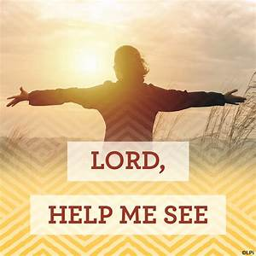
As Jesus left Jericho with his disciples and a large crowd, Bartimaeus (that is, the son of Timaeus), a blind beggar, was sitting at the side of the road. When he heard that it was Jesus of Nazareth, he began to shout and to say, ‘Son of David, Jesus, have pity on me.’ And many of them scolded him and told him to keep quiet, but he only shouted all the louder, ‘Son of David, have pity on me.’ Jesus stopped and said, ‘Call him here.’ So they called the blind man. ‘Courage,’ they said ‘get up; he is calling you.’ So throwing off his cloak, he jumped up and went to Jesus. Then Jesus spoke, ‘What do you want me to do for you?’ ‘Rabbuni,’ the blind man said to him ‘Master, let me see again.’ Jesus said to him, ‘Go; your faith has saved you.’ And immediately his sight returned and he followed him along the road.
The Gospel of the Lord

